Image transformations:

Vertical Flip:

Skew:

Distort:

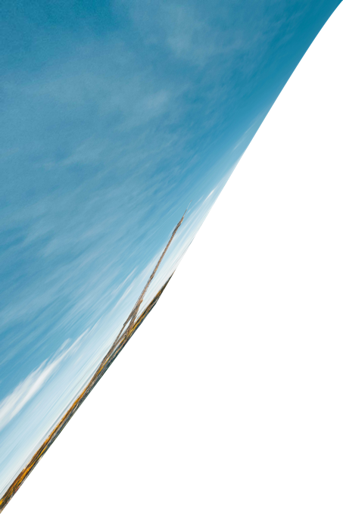

Perspective:

Wrap:

Image adjustments:

Curves:

Levels:

Black and white:

Exposure:

Invert:

